

**CS352 – Software Engineering II**

**Phase 1**

**2015**

**Project Team**

|  |  |  |  |
| --- | --- | --- | --- |
| **ID** | **Name** | **Email** | **Mobile** |
| 20120183 | Reham Sami Taie | reham.taie@hotmail.com | 01110132743 |
| 20120180 | Romisaa Attia Hussien | roma.attia@gmail.com | 01122797031 |
| 20120190 | Sara Fouad | sarafouad_111@hotmail.com | 01149026534 |
| 20120449 | Hend Mostafa | [Hendmostafa285@gmail.com](mailto:Hendmostafa285@gmail.com) | 01115015495 |

**Staff: Dr Mohammad El-Ramly m.elramly@fci-cu.edu.eg**

**TAs: Eng Mohamed Samir m.samir@fci-cu.edu.eg**

# Your Restful API

|  |  |
| --- | --- |
| **Service name** | **postservice** |
| **Input type** | **POST** |
| **Service URL** | **http://fci-sweapps.appspot.com/rest/ postservice** |
| **Parameters** | |  |  | | --- | --- | | **NAME** | **Description** | | **Post** | **The post** | | **Post_To** | **Name of timeline** | |
| **Example request** | **POST**  **http://fci-swe-apps.appspot.com /rest/postservice?Post=Hellooo&Post_To=reham** |
| **Example response** | **It will take the post and to whom the post will be sent and put them in posts table and the sender is the active user** |

|  |  |
| --- | --- |
| **Service name** | **createpageService** |
| **Input type** | **POST** |
| **Service URL** | **http://fci-sweapps.appspot.com/rest/ createpageService** |
| **Parameters** | |  |  | | --- | --- | | **NAME** | **Description** | | **pageName** | **Name of the page** | | **Category** | **Page Category** | | **pageType** | **Page type (education)** | | **pagePrivacy** | **Privacy of page** | |
| **Example request** | **POST**  **http://fci-swe-apps.appspot.com /rest/** **createpageService?pageName=FCI&Category=education&**  **pagePrivacy=public** |
| **Example response** | **It will take the name of the page and create it with it's type, category and privacy and save them in a table.** |

|  |  |
| --- | --- |
| **Service name** | **likepageService** |
| **Input type** | **POST** |
| **Service URL** | **http://fci-sweapps.appspot.com/rest/ likepageService** |
| **Parameters** | |  |  | | --- | --- | | **NAME** | **Description** | | **p** | **Name of the page** | |
| **Example request** | **POST**  **http://fci-swe-apps.appspot.com /rest/** **likepageService?p=FCI** |
| **Example response** | **The user will enter the name of the page he want to like then the page will be liked** |

|  |  |
| --- | --- |
| **Service name** | **EnterPageService** |
| **Input type** | **POST** |
| **Service URL** | **http://fci-sweapps.appspot.com/rest/ EnterPageService** |
| **Parameters** | |  |  | | --- | --- | | **NAME** | **Description** | | **p** | **Name of the page** | |
| **Example request** | **POST**  **http://fci-swe-apps.appspot.com /rest/** **EnterPageService?p=FCI** |
| **Example response** | **The user will enter the name of the page and the service will count the number of seen of the posts** |

|  |  |
| --- | --- |
| **Service name** | **TimelinePostService** |
| **Input type** | **POST** |
| **Service URL** | **http://fci-sweapps.appspot.com/rest/ TimelinePostService** |
| **Parameters** | |  |  | | --- | --- | | **NAME** | **Description** | | **PostType** | **Timeline post** | | **TimelineName** | **Name of the timeline** | | **Post** | **The post** | | **Feeling** | **Feeling of the post (happy,sad)** | | **Privacy** | **Who can see the post** | |
| **Example request** | **POST**  **http://fci-swe-apps.appspot.com /rest/** **TimelinePostService?PostType=TimelinePost&TimelineName=reham&post=helloo&Feeling=Happy**  **&Privacy=Public** |
| **Example response** | **It will take everything related to the post and the post itself and save them to a table using builder design pattern and it will display all the post related to a specific timeline** |

|  |  |
| --- | --- |
| **Service name** | **PageService** |
| **Input type** | **POST** |
| **Service URL** | **http://fci-sweapps.appspot.com/rest/ PageService** |
| **Parameters** | |  |  | | --- | --- | | **NAME** | **Description** | | **PostType** | **Page post** | | **TimelineName** | **Name of the page** | | **Post** | **The post** | | **Feeling** | **Feeling of the post (happy,sad)** | | **Privacy** | **Who can see the post** | |
| **Example request** | **POST**  **http://fci-swe-apps.appspot.com /rest/** **PageService? PostType=PagePost&TimelineName=FCI&post=helloo**  **&Feeling=Happy&Privacy=Public** |
| **Example response** | **It will take everything related to the post and the post itself and save them to a table using builder design pattern and it will display all the post related to a specific page** |

|  |  |
| --- | --- |
| **Service name** | **HashtagService** |
| **Input type** | **POST** |
| **Service URL** | **http://fci-sweapps.appspot.com/rest/ HashtagService** |
| **Parameters** | |  |  | | --- | --- | | **NAME** | **Description** | | **Hashtag** | **Hashtag name** | | **post** | **The post** | |
| **Example request** | **POST**  **http://fci-swe-apps.appspot.com /rest/** **HashtagService? Hashtag=IS&post=helloooo** |
| **Example response** | **The service will take the name of the hashtag and create a page of the name of the hashtag and this page will include all related posts of the hashtag.** |

|  |  |
| --- | --- |
| **Service name** | **HashtagcountService** |
| **Input type** | **POST** |
| **Service URL** | **http://fci-sweapps.appspot.com/rest/ HashtagcountService** |
| **Parameters** | |  |  | | --- | --- | | **NAME** | **Description** | | **Hashtag** | **Hashtag name** | |
| **Example request** | **POST**  **http://fci-swe-apps.appspot.com /rest/** **HashtagcountService? Hashtag=IS** |
| **Example response** | **The service will take the name of the hashtag and count the number of posts in each hashtag to make the top 10 hashtags** |

# Class diagram design

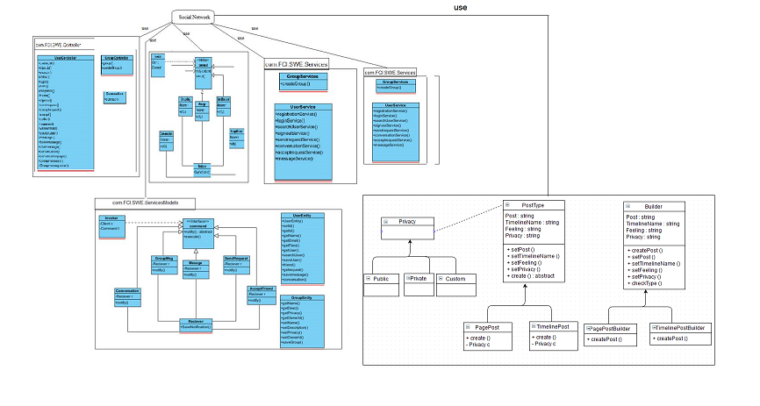

# Trello workspace screenshot

# 

# Github repository link

**https://github.com/Reham-Taie/FCI-CS352-SWE-Team.git**